SYMETRIX WORK INSTRUCTIONS
75-0004 – Asm, Repair Kit, xIn 12 / xOut 12 Power Supply

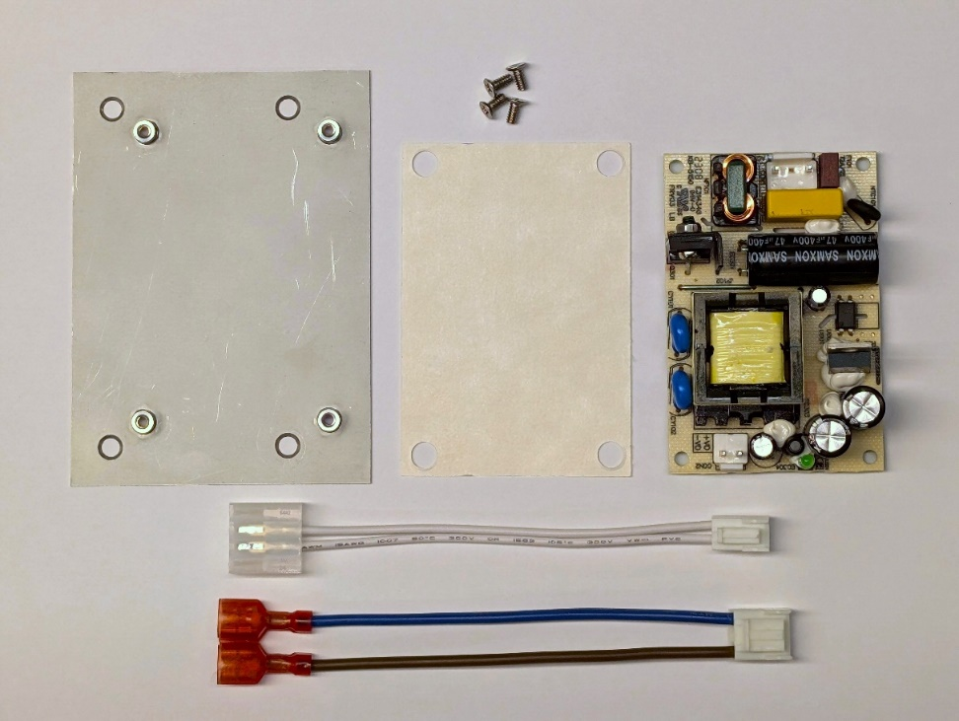
INCLUDED PARTS
B
A
- 1x 11-0344-1 Adapter Plate
D
C
- 4x 11-0345-1 Screw, Phillips,
Flat Head
- 1x 11-1661-B Power
Supply Insulator
- 12-0063 Power Supply, 30W, 24V
- 40-0048-B AC Input Cable Assembly (P/N for complete IEC assembly, only the connector and brown and blue wires are needed.)
E
F
- 40-0052-A DC Output
Cable Assembly

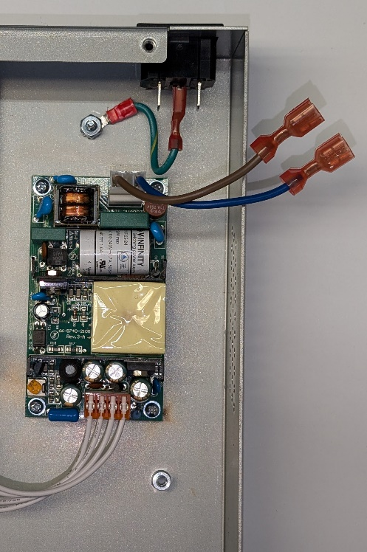
REQUIRED TOOLS

Philips screwdriver

Needle nose pliers (optional)

IMPORTANT
This procedure should only be performed
by a qualified technician.

PROCEDURE
STEP 1. Disconnect AC power cable from unit.
STEP 2. Remove top cover, 3 screws at rear.
STEP 3. Disconnect brown and blue wires from IEC
AC power jack. This can be done by hand, optionally
use needle nose pliers. Do not disconnect Ground wire.

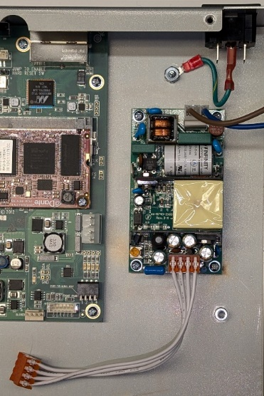
STEP 4. Disconnect DC power connector
from main PCB.
STEP 8. Install Power Supply (12-0063) with the 4 Phillips screws removed at Step 5. Note the orientation,
3 pin AC input toward the IEC AC power connector.
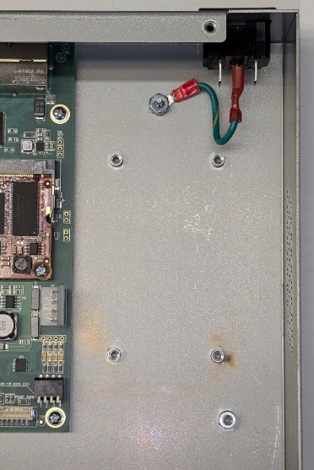
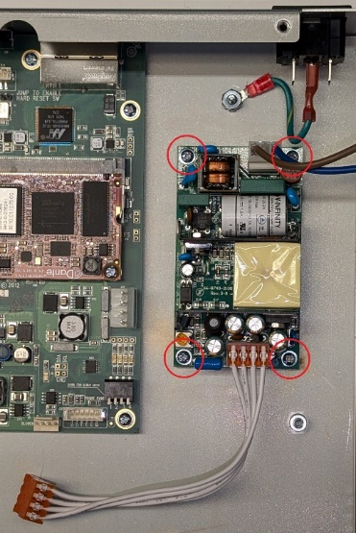
STEP 5. Remove
the 4 screws securing the power supply and set aside. Remove power supply and insulating material.
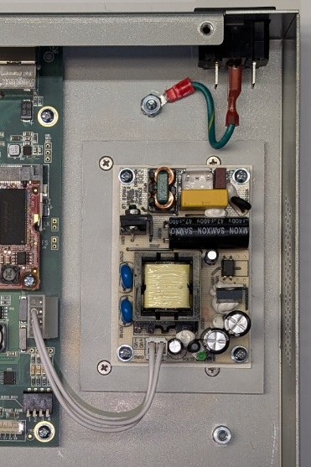
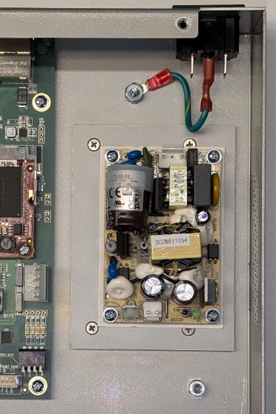
STEP 9. Install
DC Output Cable Assembly
(40-0052-A).
STEP 6. Install Adapter Plate (11-0344-1) with the 4 Phillips Flat Head Screws (11-0345-1).
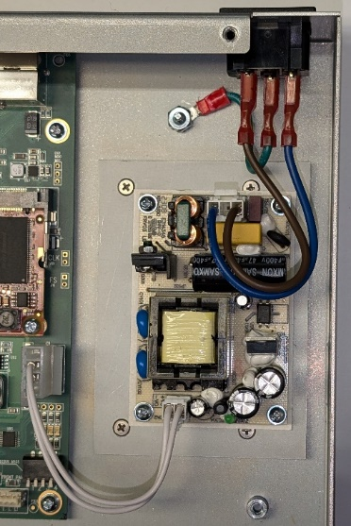
STEP 10. Install AC Input Cable Assembly (40-0048-B) ensuring the brown wire is connected to the terminal nearer the unit’s interior, and blue to the terminal nearer the unit’s sidewall.
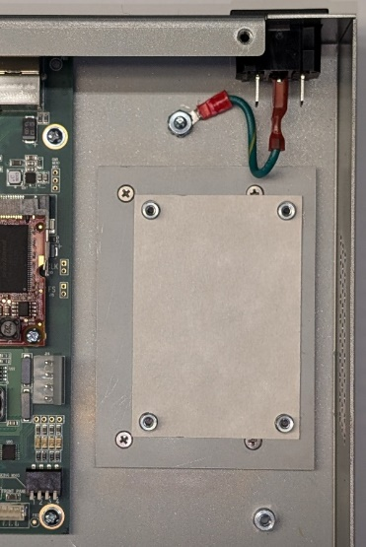
STEP 7. Install
Power Supply Insulator (11-1661-B).
STEP 11. Reattach the top cover.

